QWS Endpoint Installation Guide
The process involves installing the latest Oracle VirtualBox type-2 hypervisor to your home computer and then importing the provided OVA.
Once that VM is imported, go through a QWS registration process and make your VPN connection to the BicDroid office from that imported VM.
- Go to this Web site to download the latest version of VirtualBox.
https://www.virtualbox.org/

VirtualBox is available for many OS platforms, download the one for yours.
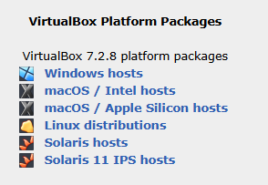

Follow typical install steps for VirtualBox, example screens:
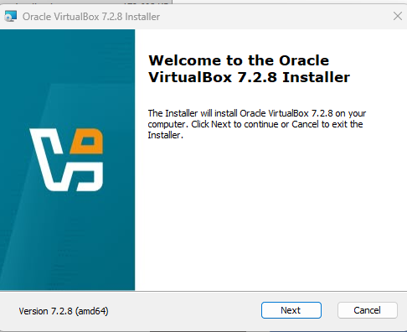
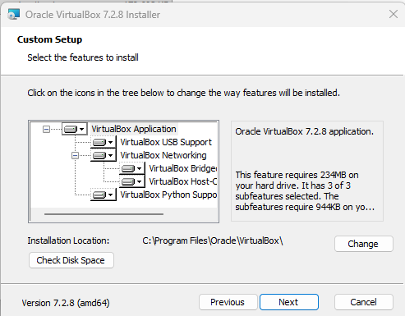
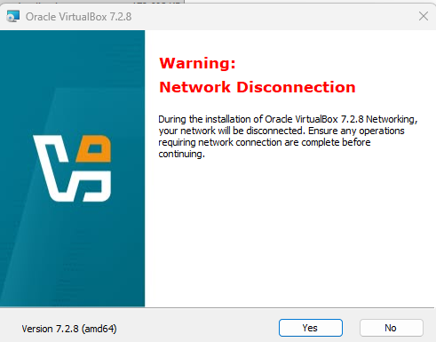
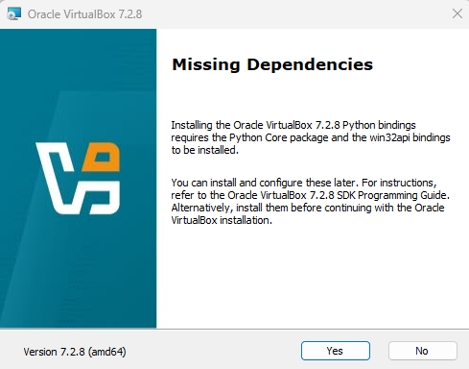
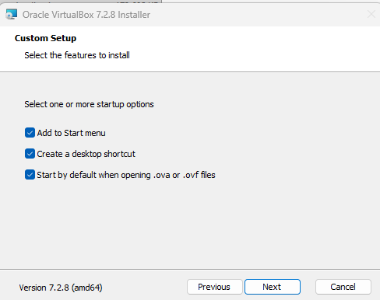
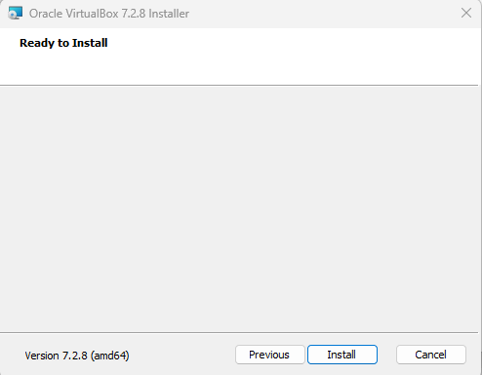
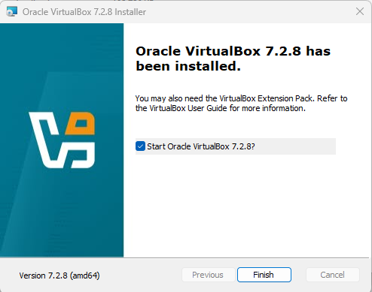
- Download and import the OVA.
Download link:
https://qws.bicdroid.com:4443/ova/18.ova
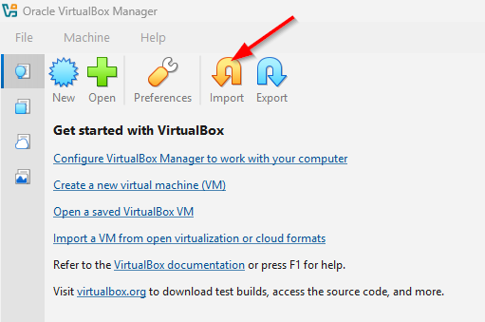

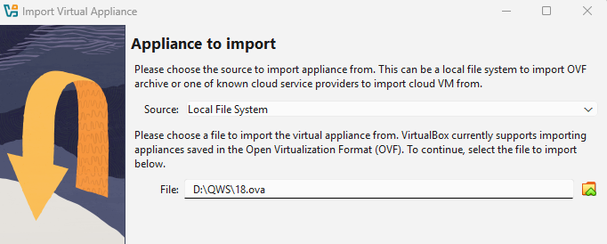

- Import the appliance with minimum default settings. The CPU and RAM settings can be modified here by double clicking the values. Do not exceed the capability of the host machine:
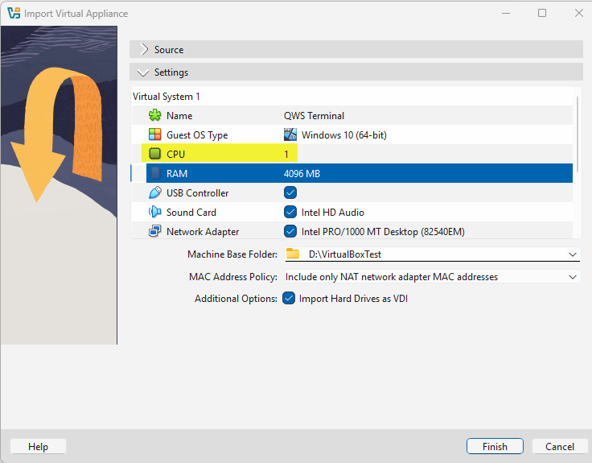

- Depending on the host machine, the import process will take several minutes to complete. The completion time estimate may fluctuate, but should not exceed 10 minutes. Once finished, the user can also re-adjust CPU and RAM settings under Machine Settings System if desired. Otherwise, click start to launch the QWS Terminal:
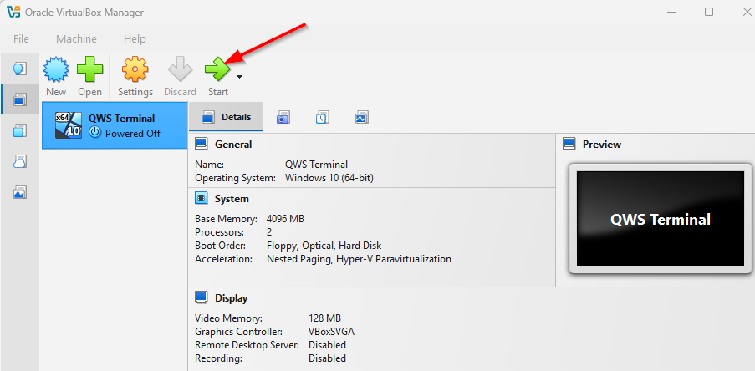

- Login as “User” and assign yourself a password that is for this QWS VM which runs Windows 10.
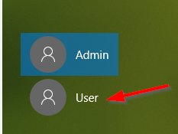
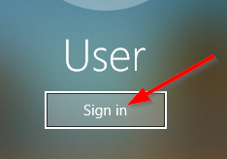
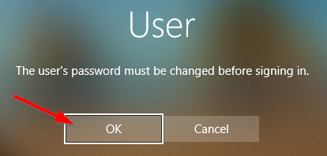
Enter a password of your choice that will be used when you power ON this QWS VM:
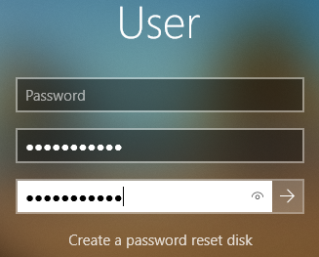
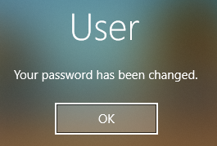
After the terminal has completed the boot process, wait 1-2 minutes for the network connection to be established in the background. Click anywhere on the screen, and then click “User” in lower left-hand corner to automatically login. Wait for the registration page to load, enter a valid email address and click “Send Verification Code”:
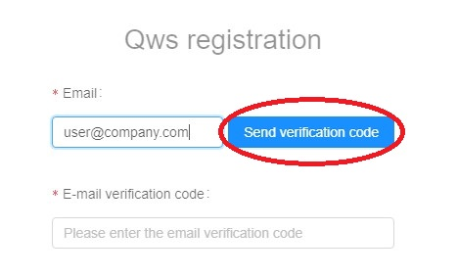
10. The code will be sent to the address entered, and is valid for approximately 5 minutes:
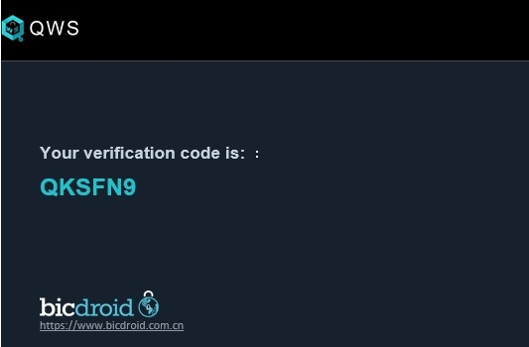

11. After receiving the code, enter it into the field, fill in other fields on the form and click “Register”. If an account already exists, click “Sign In” in the lower right-hand corner:
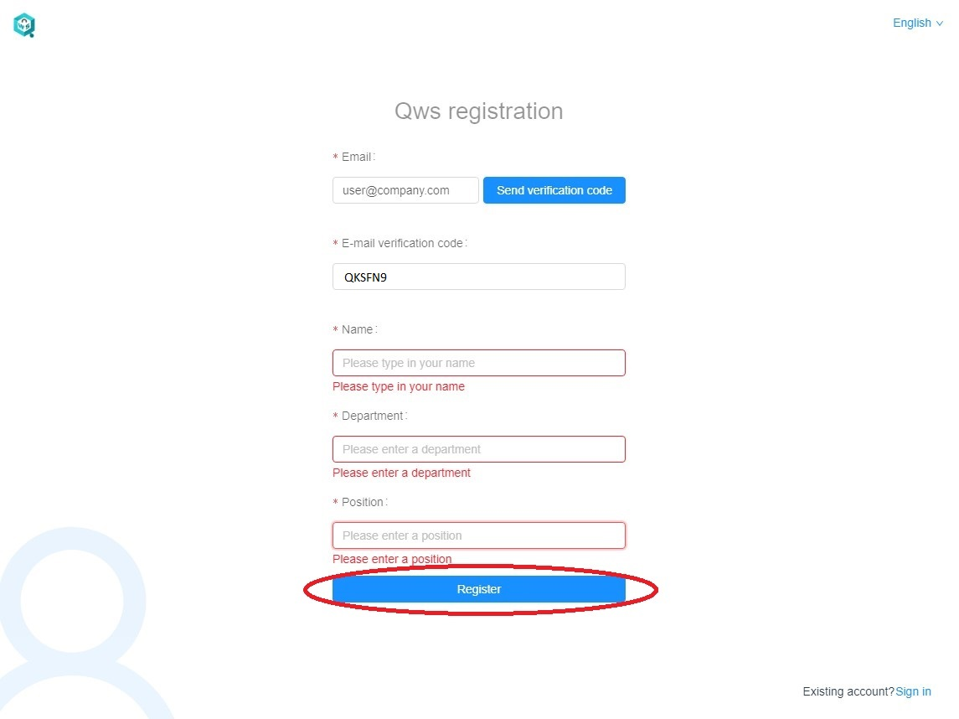

12. After the process is successfully completed, the next screen will be shown as below:
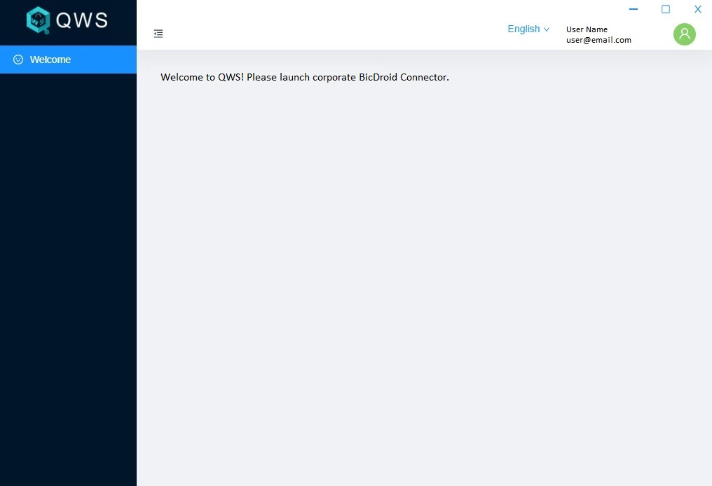

13. Next, on the Windows taskbar in the lower right-hand corner, click on the ^ symbol, and then right click on the connection icon as seen below, and then click “Connect”:
*** If it’s not yet visible, logoff and re-login to this QWS VM ***
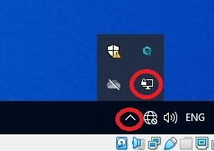 | 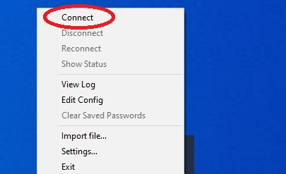

14. The next dialog prompt will require the username and password provided by the IT admin. Enter username and password – for improved security it is recommended to leave the “Save Password” field unchecked. Click “OK” to connect:
*** These are your AD login credentials ***
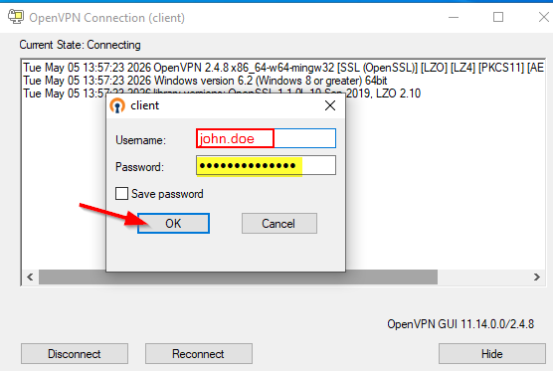

15. There should be a message indicating a successful connection, and an assigned IP address. The BicDroid Connector icon in the Windows taskbar should be green. If the icon is yellow, contact the IT admin to troubleshoot the problem:

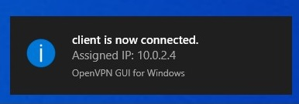 | 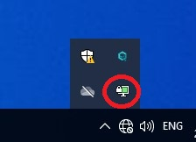

16. All corporate resources that have been assigned should now be accessible.

